SIMATS ENGINEERING
ASSESSMENT TOOL 1 (AT1)
COURSE NAME: INTERNET PROGRAMMING | COURSE CODE: CSA43
CO-1: Develop well-structured, standards-compliant web pages using HTML/XHTML and XML (L2)
Weightage: 40% | Total Marks: 30 Marks
Student Name: K.Nanda Kishore Reddy | Register Number: 192411161
Assessment Tool: Application-Based Questions | Status: Submitted & Verified

Question 1: Online Symposium Portal
Scenario: A college is developing an online symposium registration portal. The following HTML structure and HTTP interaction is observed:
<form action="/register" method="POST">
<input type="text" name="name">
<input type="email" name="email">
<button>Submit</button>
</form>

1.1 Identify appropriate HTML5 semantic elements missing in the structure.
• Missing Structural Landmarks: <main>, <section>, <header>, and <footer> tags.
• Missing Form Grouping: <fieldset> and <legend> elements to describe participant details.
• Missing Form Control Labels: <label for="..."> elements associated with inputs for screen readers & click targets.
• Missing Root Wrappers: <!DOCTYPE html>, <html>, <head>, <title>, and <meta charset="UTF-8">.
1.2 Modify the structure to make it standards-compliant.
<!DOCTYPE html>
<html lang="en">
<head>
<meta charset="UTF-8">
<meta name="viewport" content="width=device-width, initial-scale=1.0">
<title>Online Symposium Registration Portal</title>
</head>
<body>
<header><h1>Annual Tech Symposium 2026</h1></header>
<main>
<section aria-labelledby="form-heading">
<h2 id="form-heading">Student Registration Form</h2>
<form action="/register" method="POST" id="registrationForm">
<fieldset>
<legend>Participant Information</legend>
<div class="form-group">
<label for="student-name">Full Name *</label>
<input type="text" id="student-name" name="name" required autocomplete="name" placeholder="e.g. Alex Johnson">
</div>
<div class="form-group">
<label for="student-email">Email Address *</label>
<input type="email" id="student-email" name="email" required autocomplete="email" placeholder="e.g. alex@university.edu">
</div>
<button type="submit">Submit Registration</button>
</fieldset>
</form>
</section>
</main>
<footer><p>&copy; 2026 SIMATS Engineering</p></footer>
</body>
</html>

1.3 Interpret the HTTP request generated during form submission.
When submitted, the browser encapsulates form input data into an HTTP POST request body:
POST /register HTTP/1.1
Host: symposium.simats.edu
Content-Type: application/x-www-form-urlencoded
Content-Length: 37
name=Alex+Johnson&email=alex%40university.edu

1.4 Analyze the HTTP response cycle from server to browser.
The communication follows a 5-step Post/Redirect/Get (PRG) cycle to process data and render confirmation without duplicate submission risks:
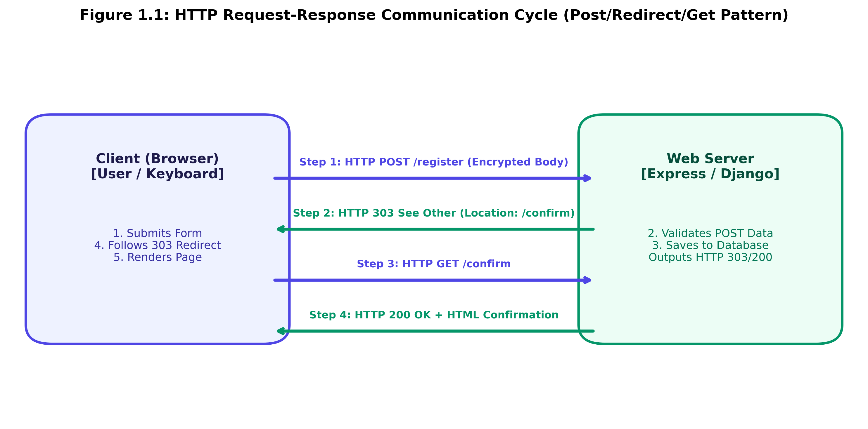
1.5 Suggest improvements for usability and accessibility.
1. Accessibility (WCAG 2.1): Explicit <label for="id"> bindings, aria-required="true", and high-contrast :focus-visible outlines.
2. Usability (UX): Autocomplete attributes, client-side input validation, clear placeholders, and disabling submit buttons on click to prevent double submissions.
Question 2: Cross-Browser Compatibility Issue
Scenario: A company website shows inconsistent layout across browsers using unclosed tags:
<html>
<head>
<title>Company</title>
</head>
<body>
<div>
<h1>Welcome
<p>About us
</div>
</body>
</html>

2.1 Identify improper nesting and missing closing tags.
• Missing <!DOCTYPE html> declaration (forces Quirks Mode).
• Unclosed <h1> tag (<h1>Welcome missing </h1>).
• Unclosed <p> tag (<p>About us missing </p>).
• Improper Nesting: <p> tag placed inside unclosed <h1> tag (block-level tags forbidden inside headings).
2.2 Analyze how different browsers may interpret this structure.
Modern HTML parsing engines auto-close <h1> when encountering <p>, yielding <h1>Welcome</h1><p>About us</p>. However, missing DOCTYPE triggers Quirks Mode, causing font sizing, line height, box-model, and margin collapsing inconsistencies across WebKit, Blink, and Gecko.
2.3 Identify missing semantic elements.
Missing <header>, <main>, <section>, <footer>, lang="en", and viewport meta tags.
2.4 Provide a corrected W3C-compliant HTML structure.
<!DOCTYPE html>
<html lang="en">
<head>
<meta charset="UTF-8">
<meta name="viewport" content="width=device-width, initial-scale=1.0">
<title>Company - Official Website</title>
</head>
<body>
<header><h1>Welcome to Our Company</h1></header>
<main>
<section>
<h2>About Us</h2>
<p>We are a global provider of innovative technology solutions.</p>
</section>
</main>
<footer><p>&copy; 2026 Company Inc.</p></footer>
</body>
</html>

2.5 Suggest techniques to ensure cross-browser compatibility.
• Enforce Standards Mode with <!DOCTYPE html> at line 1.
• Automated W3C Validation via W3C validator tools.
• CSS Reset / Normalization (normalize.css).
• Cross-browser testing with Playwright & BrowserStack.
Question 3: Form Submission Failure
Scenario: Form fails to send data with configuration:
<form action="/submit" method="GET">
<input type="text" name="username">
<input type="password" name="password">
<button type="button">Login</button>
</form>

3.1 Identify issues in the form configuration.
1. Incorrect Button Type: type="button" has no default submission behavior.
2. Insecure Transmission Method: method="GET" exposes passwords in URL query parameters.
3. Missing Form Labels and Security Attributes.
3.2 Analyze why the HTTP request is not triggered.
Buttons with type="button" fire click events but DO NOT dispatch form submit events. Without a submit event, the browser never constructs or sends an HTTP request.
3.3 Interpret the role of GET method and security risks.
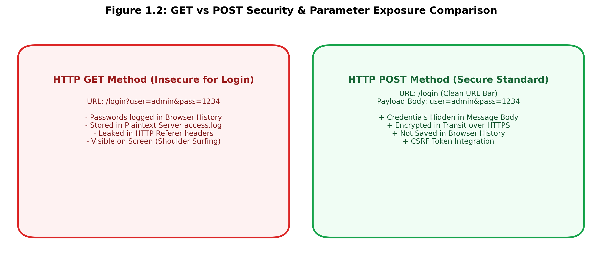
3.4 Propose a corrected implementation.
<!DOCTYPE html>
<html lang="en">
<head>
<meta charset="UTF-8">
<title>Secure Login</title>
</head>
<body>
<main>
<form action="https://example.com/api/login" method="POST" autocomplete="on">
<div>
<label for="username">Username</label>
<input type="text" id="username" name="username" required autocomplete="username">
</div>
<div>
<label for="password">Password</label>
<input type="password" id="password" name="password" required autocomplete="current-password">
</div>
<button type="submit">Login</button>
</form>
</main>
</body>
</html>

3.5 Suggest improvements for secure data transmission.
• Mandatory HTTPS (TLS/SSL encryption).
• POST method for body payload transmission.
• Anti-CSRF token integration.
• Security Headers: Cache-Control: no-store, HSTS, and Content-Security-Policy.

Code of Conduct:
I, K.Nanda Kishore Reddy (Reg No: 192411161), certify that this submission is my original work and that I have adhered to the guidelines specified for this assessment. I understand that any violation of academic integrity rules will result in disciplinary action.
Signature of the student: K.Nanda Kishore Reddy(192411161)

